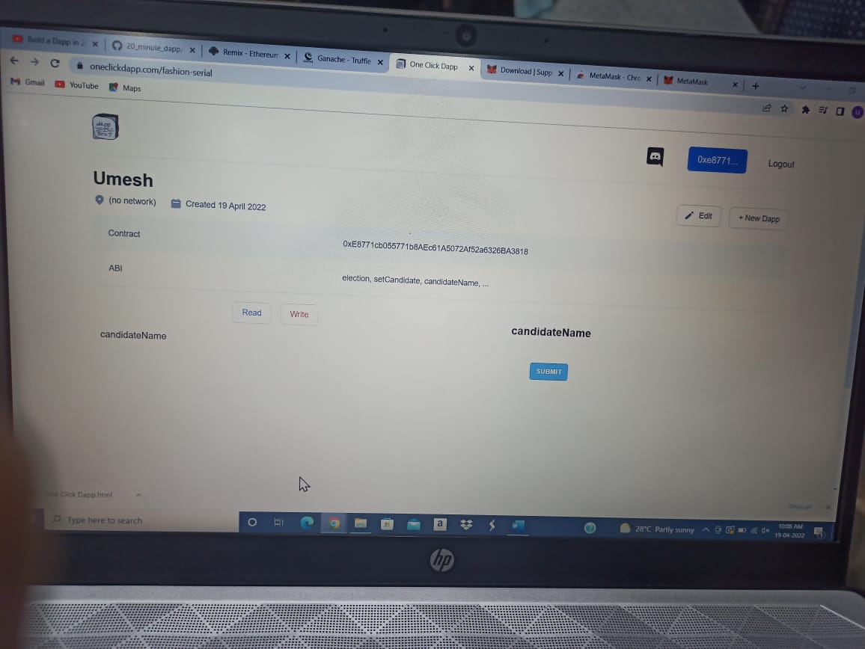

LINK: https://oneclickdapp.com/fashion-serial